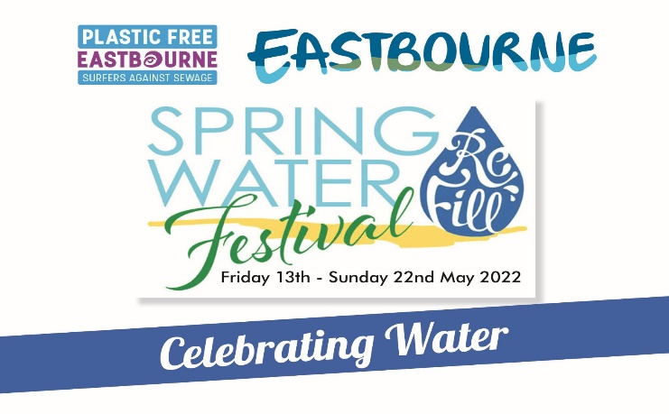
CREATIVE COMPETITION ENTRY FORM

NAME: ………………………………………………………………………………………….
(Full names of minors will only be published on our website or elsewhere with parental permission)

AGE GROUP: (Please underline or highlight)
KS2 KS3 KS4 KS5 ADULT

CONTACT DETAILS:
NAME OF SCHOOL/ COLLEGE ………………………………………………………
NAME OF CONTACT TEACHER/LECTURER ……………………………………
CONTACT EMAIL……………………………………………………………………….
ADULTS: Please give your postal address and contact email
………………………………………………………………………
………………………………………………………………………..
…………………………………………………………………………
ALL AGE GROUPS: Please ensure that your entry has your Name and Age Group included on ALL pages of your entry.
WRITTEN ENTRIES should ideally be sent by email either as attachment or scan to suedixonjwg@gmail.com
Hard copy can be sent if preferred to Sue Dixon, 8 Gore Park Road, Eastbourne BN21 1TQ.
Please liaise with Sue by email for delivery of Video entries.
All entries must arrive by 10pm Friday 13th May 2022

